Adding Meta tags/SEO section to law landing pages
- Adding fields to the content type.
I have added three Meta tags, SEO Description Text and SEO Title fields with following machine name and field type in Law Landing Pages content type.

Field Label | Field_machine_name | Field_type
Meta Tags | field_meta_tags | Meta Tags
SEO Description Text | field_teaser_text | Text (plain, long)
SEO Title | field_seo_title | Text (plain)

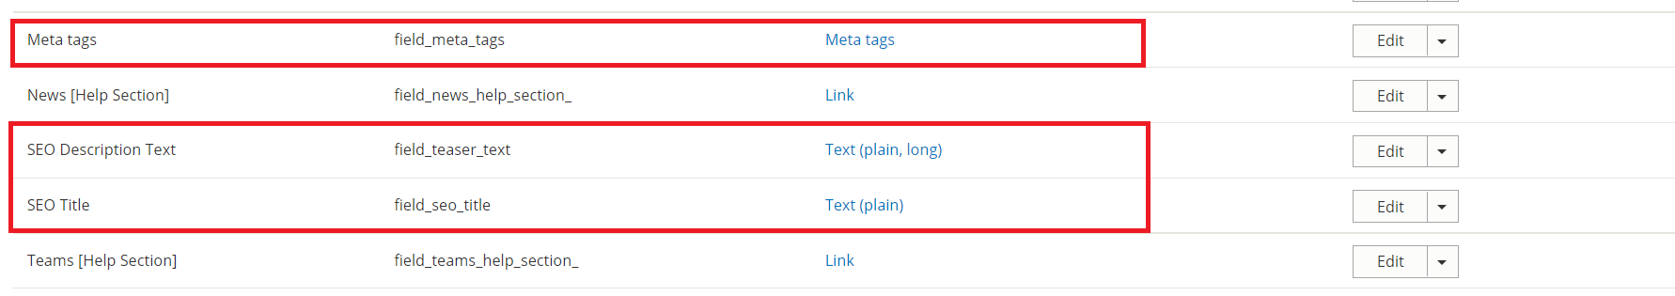

Note: Keep same field name same and field type.

- Add Tab Group in manage form display.
I have added teo tab groups Details and SEO / Meta-tags. Then I have moved the Title and SEO Title into under details tab and moved SEO Description Text and
Meta tags under SEO / Meta-tags tabs group. You can put in only 1 tab group if you want.

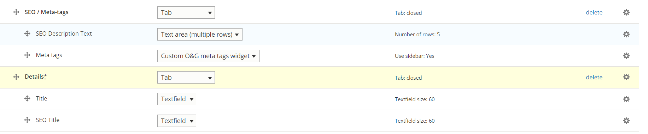

- Disabling the fields from Manage display settings.
I have disabled the newly added fields so they will not display on law landing pages. Only on the backend source code we can see these fields.

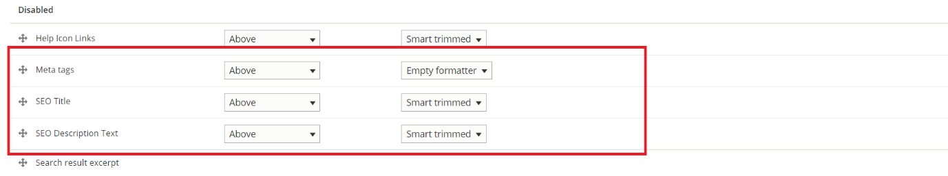
Edit Law Landing Page screenshot.
You can see the new fields in Details ad SEO/meta tags tab groups on edit pages.
